**Preliminary Report**

James Mwakichako Manoj Kumar

**Predicting 4th Month Churn Rate**

Number of Rows = 11925

Class Distribution:

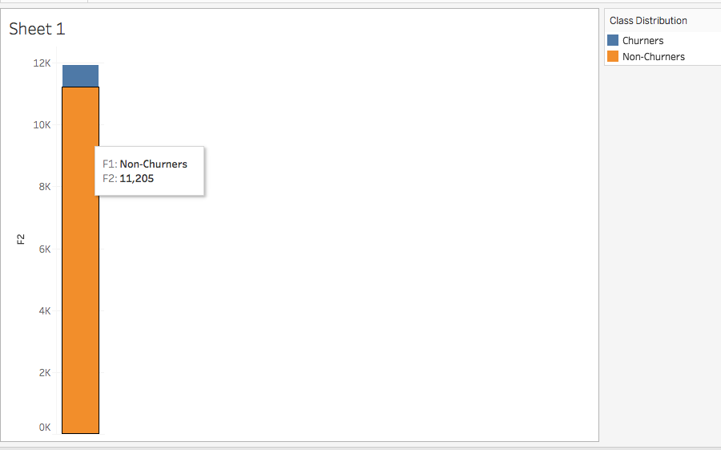

The skewness towards Non-Churners adversely affects precision

Predicting 4th Month:

We used Jan-March 2014 for our analysis as this contained the most number of subscribers. We used decision tree and logistic regression models.

|  |  |  |
| --- | --- | --- |
|  | **Actual Churners** | **Actual – Non Churners** |
| **Predicted Churners** | 226 | 219 |
| **Predicted Non-Churners** | 55 | 4153 |

Precision = 0.51

Recall = 0.8

Top 10 Most Important Features

Using the decision Tree model, below are the top 10 most important features.

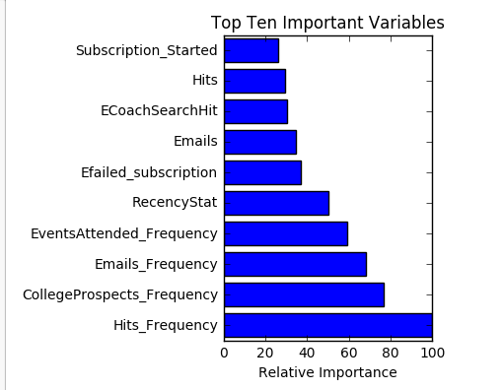

**Predicting Churn at Anytime**

We cleaned the whole database and used 75% for testing and the remaining 25% for testing to predicting churn.

Number of Rows = 133419

**Class Distribution**

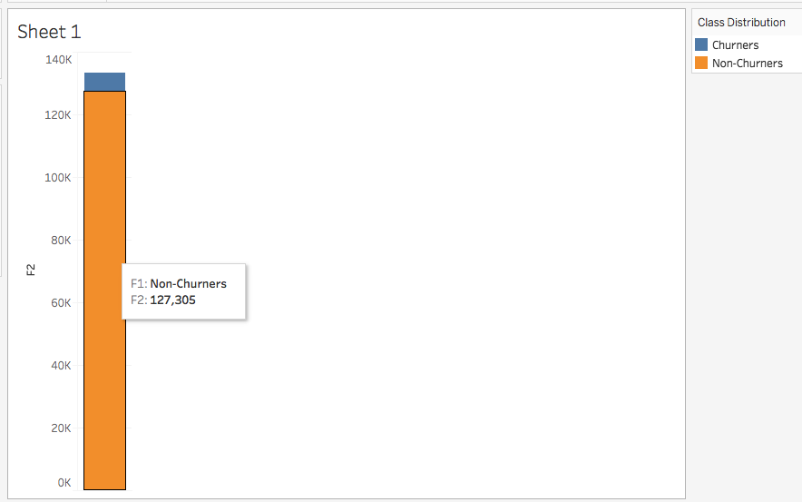

**Confusion Matrix**

|  |  |  |
| --- | --- | --- |
|  | **Actual Churners** | **Actual – Non Churners** |
| **Predicted Churners** | 1323 | 1332 |
| **Predicted Non-Churners** | 168 | 30532 |

**Precision = 0.5**

**Recall = 0.89**

**Feature Importance**

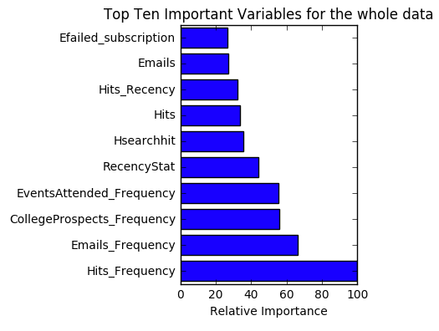

**Further Work**

* Explore Cohort Analysis and Time Series models
* Talk to the team more on significance of some columns eg Hits_Recency as this would impact how we impute missing values